JOB DESCRIPTION:  Public Affairs Officer | 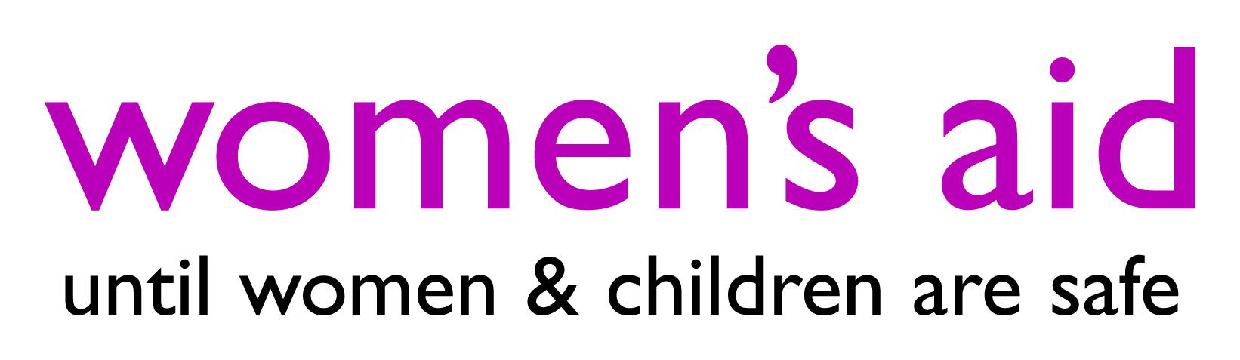
Reports to Public Affairs Manager
Location Flexible - role will require travel to London and occasionally to Bristol
Annual Salary £27,971 (based on pay scale point 29-33 + ILW of £3,483.94 p.a. where eligibility criteria is met)
Length of contract Permanent, 37 hours per week (full-time, with flexible hours)
Main PURPOSE
As the Public Affairs Officer in the new External Affairs team at Women’s Aid, you will play a pivotal role in our government and parliamentary engagement work. This will include leading on monitoring parliamentary activity and identifying opportunities for Women’s Aid to influence the political agenda and ensure parliamentarians are kept up to date on issues related to domestic abuse. You will play a pivotal role in supporting our influencing work on key pieces of legislation, Women’s Aid’s next big campaign and assisting Women’s Aid’s secretariat role to the All-Party Parliamentary Group (APPG) on Domestic Violence and Abuse. Alongside organising meetings and events for the APPG and with key political stakeholders, you will lead on the development of public affairs and campaigns materials, including policy bulletins, briefings, speaking notes and letters to government ministers.

DUTIES AND KEY RESPONSIBILITIES
- Public Affairs
  - Carry out regular political monitoring, keeping the team updated with important developments for Women’s Aid, identifying opportunities for influence and providing analysis on policy announcements.
  - Draft newsletters, correspondence, and website and social media content for parliamentarians, Women’s Aid’s member services and campaigners on a range of campaign and policy priorities.
  - Support Women’s Aid’s work on key pieces of legislation - responding to queries, drafting briefings and parliamentary questions, working with Parliamentarians on draft amendments, and the development of joint sector work.
  - Facilitate Women’s Aid’s programme of engagement with Parliamentarians and other key stakeholders, including by contributing to the development of a parliamentary engagement strategy, carrying out research, drafting correspondence and briefings, and representing Women’s Aid at external meetings.
  - Work with the Policy team in responding to a range of policy requests from government and Parliament, including assisting with developing consultation responses, evidence submissions and policy briefings.
  - Coordinate and keep up to date records of Women’s Aid’s engagement with Parliamentarians and other key stakeholders and progress on our next big campaign and supporting the team’s ongoing monitoring and evaluation including using Hansard.
  - Assist Women’s Aid’s secretariat role to the APPG on Domestic Violence and Abuse, including organising meetings and events, responding to queries from the public and APPG officers, researching and writing briefings, attending meetings and taking minutes and providing additional administrative support.
  - Shape and deliver events related to our priorities, including policy webinars, parliamentary events for International Women’s Day, and Women’s Aid’s Public Policy Conference and Annual Conference, with logistical support from the Events Officer.
  - Lead on projects that widen participation in Women’s Aid public affairs and campaigning work, including organising meetings with survivors and our member services.

- General responsibilities
  - Provide general administrative support to the External Affairs team as required, including attending meetings and events and taking minutes, deputising for the Public Affairs Manager where required.
  - Take direction and lead on projects and priorities from your line manager, which may vary from time to time.
  - Contribute to team meetings and organisational priorities, and to participate in supervision and appraisal meetings
  - Carry out word-processing, filing, and administrative tasks necessary to comply with the job description.
  - Abide by all organisational policies, codes of conduct and practice, and to work within a framework of equal opportunities and anti-discriminatory practice.

PERSON SPECIFICATION: Public Affairs Officer
EXPERIENCE
Essential:
- Previous experience of working in a political role or exposure within parliamentary institutions;
- Experience of engaging with stakeholders at a national level;
- Supporting the delivery of projects and campaigns;
- Liaising and working with external organisations and individuals, including via correspondence;
- Drafting written communications such as briefings, written parliamentary questions, government consultations, parliamentary inquiry responses, and political analysis;
- Maintaining administrative systems.

Desirable:
- Experience of working on campaigns or within the charity sector;
- Experience of engaging with government and civil servants or other public sector agencies;
- Experience of working with political monitoring systems such as Dods or Dehavilland;
- Experience of working with a database or Customer Relationship Management (CRM) system.

KNOWLEDGE AND SKILLS
Essential:
- Effective oral communication skills, including the ability to deal with a range of enquiries to a busy team;
- Understanding of the workings of Parliament and government;
- Excellent written communication skills, including the ability to write copy for a range of audiences and formats e.g., briefings, speaking notes, consultation submissions, correspondence;
- Attention to detail and high level of accuracy;
- Excellent organisational skills, with the ability to organise and assist with events;
- Proficient IT skills (Microsoft Office).

Desirable:
- Ability to communicate sensitively about the issues facing women and children affected by domestic abuse.
- Knowledge of the issues facing women and children affected by domestic and abuse;
- A clear understanding of the work of Women’s Aid and our work on domestic abuse.

OTHER REQUIREMENTS
Essential:
- Able to demonstrate a commitment and sensitivity of the aims and objectives of Women’s Aid;
- Commitment to anti-racism and anti-discriminatory practice and equal opportunities.

SUMMARY OF TERMS AND CONDITIONS OF EMPLOYMENT
Terms of appointment: Confirmation of appointment will be subject to the satisfactory completion of a probationary period. This will normally be of six months (less for short term contracts). During this time an employee will be expected to establish their suitability for the post. During the probationary period employment may be terminated in writing, giving one week's notice by either party (this may be waived by mutual agreement). Only any statutory dismissal procedure will apply during the probationary period. There is no probationary period for contracts of under 3 months.

Salary: £27,971 per annum + benefits. Salary is paid in arrears through bank credit by the 25th of each month. Part time staff receive pro-rata payment based on hours worked.

Working hours: The standard working hours for this post are 37 hours per week; benefits include a generous bank holiday and annual leave package and contributory pension scheme.

Support and supervision: Women’s Aid has a commitment to providing regular supervision and support to staff with annual appraisals forming a key part of staff development. We have a training policy in place and encourage staff to take an active role in their career development plan.

Pension: Women’s Aid is enrolled with the People’s Pension scheme. Women’s Aid normally contributes 7% of salary and the employee contributes 3% towards the group pension scheme. Eligible staff will be automatically enrolled on the scheme when they have successfully completed the 3-month interim probationary review.

Annual Leave: Women’s Aid offers an annual leave entitlement of 25 days per year rising by one day per year until 30 days annual leave per year is reached. In addition, we offer 8 days public holidays plus 2 additional days in March and August. All leave entitlement is calculated pro-rata for part time employees.

Other leave: Employees have contractual rights to time off for reasons of sickness, maternity and other circumstances.

Period of notice: 1 months after your probationary period has been completed.

Union: You have a right to membership of a trade union. Women’s Aid recognises Unison.

Asylum and Immigration Act 1996: To confirm your right to work in the UK, Women’s Aid will need to see the original of at least one document from a specified list (available on the gov.uk website). Most commonly this is a British Passport.

Additional information is available on request.

